**Selenium Locators**

**Task Description:**

1. Write all possible locators for given URL on given website:

hitps://www.guvi.in/register

1. ID

2. ClassName

3. TagName

4. CSS Selector

5. Xpath

***Code:-***

|  |
| --- |
| **package** trainingtaskcompletion;  **import** java.io.File;  **import** java.io.IOException;  **import** java.time.Duration;  **import** org.openqa.selenium.By;  **import** org.openqa.selenium.OutputType;  **import** org.openqa.selenium.WebDriver;  **import** org.openqa.selenium.WebElement;  **import** org.openqa.selenium.chrome.ChromeDriver;  **import** org.openqa.selenium.io.FileHandler;  **public** **class** LocatorExample {  **public** **static** **void** main(String[] args) {  // Set the path to Chrome driver executable  // System.setProperty("webdriver.chrome.driver", "/path/to/chromedriver");  // Initialize WebDriver  WebDriver driver = **new** ChromeDriver();  // Open the URL  String url = "https://www.guvi.in/register";  driver.get(url);  driver.manage().window().maximize();  driver.manage().timeouts().implicitlyWait(Duration.*ofSeconds*(10));  // Find elements using different locators  WebElement fullNameInputById = driver.findElement(By.*id*("name"));  WebElement emailInputByClass = driver.findElement(By.*className*("form-control"));  WebElement elementByTagName = driver.findElement(By.*tagName*("input"));  WebElement signUpButtonByCss = driver.findElement(By.*cssSelector*("#signup-btn"));  WebElement elementByXPath = driver.findElement(By.*xpath*("//input[@id='password']"));  File src = elementByXPath.getScreenshotAs(OutputType.***FILE***);  // Print out attributes of the found elementsbtn  System.***out***.println("Element found by ID: " + fullNameInputById.getAttribute("outerHTML"));  System.***out***.println("Found element with ID 'fullName': " + fullNameInputById.isDisplayed());  System.***out***.println("Element found by ClassName: " + emailInputByClass.getAttribute("outerHTML"));  System.***out***.println("Found element with class 'form-control': " + emailInputByClass.isDisplayed());  System.***out***.println("Element found by TagName: " + elementByTagName.getAttribute("outerHTML"));  System.***out***.println("Found " + elementByTagName.getAccessibleName() + " elements with tag name 'input'");  System.***out***.println("Element found by CSS Selector: " + signUpButtonByCss.getAttribute("outerHTML"));  System.***out***.println(  "Found element with CSS selector 'button[type=\'submit\']': " + signUpButtonByCss.isDisplayed());  System.***out***.println("Element found by XPath: " + elementByXPath.getAttribute("outerHTML"));  System.***out***.println("Found element with XPath '//input[@id='password']': " + elementByXPath.isEnabled());  String path = System.*getProperty*("user.dir");  System.***out***.println(path);  File dest = **new** File(path + "/screenshot/LocatorExample.png");  **try** {  FileHandler.*copy*(src, dest);  } **catch** (IOException exception) {  exception.printStackTrace();  }  // Close the browser  driver.quit();  }  } |

***Output :-***

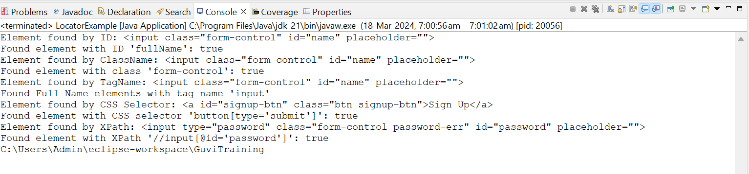

***Locator Screenshot:-***

C:\Users\Admin\AppData\Local\Packages\Microsoft.Windows.Photos_8wekyb3d8bbwe\TempState\ShareServiceTempFolder\LocatorExample.jpeg